Pseudocode Assessment – Answers

Question 1 – P2P File Sharing Algorithm
1. START
2. CONNECT TO PEER
3. IF FILE IS AVAILABLE THEN
4. DOWNLOAD FILE
5. ENDIF
6. DISPLAY "File not available"
7.END
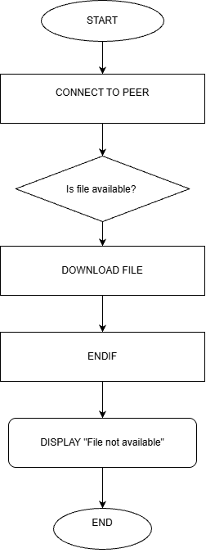

Question 2 – VoIP Call Connection Algorithm
1. START
2. CHECK INTERNET CONNECTION
3. IF INTERNET IS AVAILABLE THEN
4. CONNECT CALL
5. START VOICE COMMUNICATION
6. ELSE
7. DISPLAY "No Internet Connection"
8. ENDIF
9.END
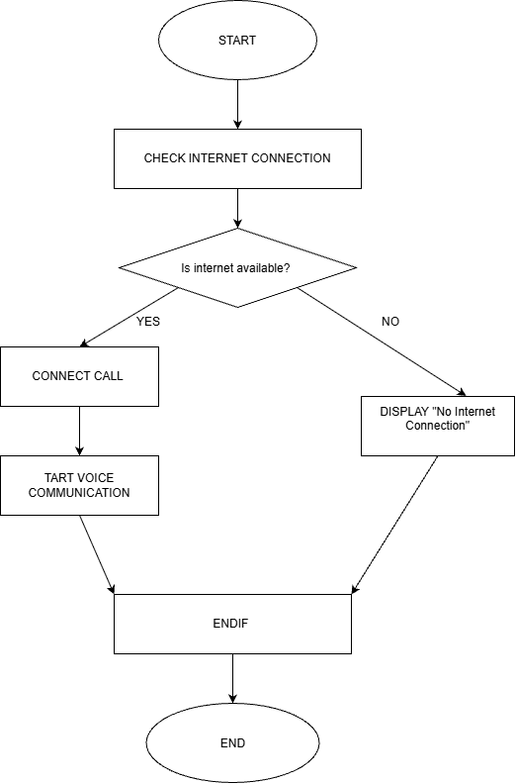

Question 3 – Overlay Network Message Routing Algorithm
1. START
2. CHECK DESTINATION NODE
3. IF DESTINATION NODE IS AVAILABLE THEN
4. SEND MESSAGE DIRECTLY
5. ELSE
6. FORWARD MESSAGE THROUGH ANOTHER NODE
7. DISPLAY "MESSAGE SENT"
8. ENDIF
9.END
